CS 405 Module Five - Encryption Activity
Figure 1: Console output showing encryption and decryption file generation.
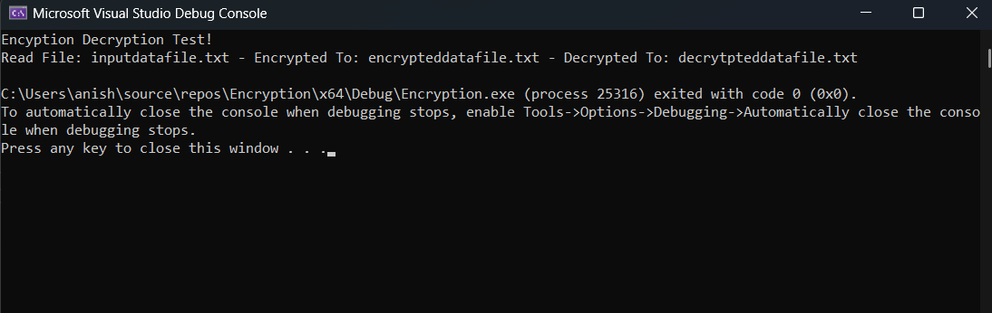
Process Summary
I completed the encryption activity by implementing XOR-based encryption/decryption across the full file character-by-character. The key index is wrapped using a modulo operation so the key repeats correctly for files longer than the password length. Next, I implemented read_file() to load the entire input text file into a single string while preserving newlines. I then implemented save_data_file() to write files using the required format: student name, a yyyy-mm-dd timestamp, the key used, and the data payload. During testing, I verified that the encrypted output differs from the plaintext and that decrypting the encrypted data with the same key reproduces the original text exactly. The program successfully generated the required encrypted and decrypted data files using the filenames defined in the source code.

